Exploring Literacy as Power: Bridging Social Justice and Critical Communication
Waode Eti Hardiyanti
Critical Reflection of Gender Bias in STEM Education

EDU 498 Literacy Learning as Social Practice

Course Instructor:
Alyse Cunzio

November 16, 2024

Critical Reflection of Gender Bias in STEM Education
The issue of gender bias in STEM education is prominent discourse in society. I have observed that STEM is one of the most emphasized fields where gender often determines who is deemed fit or unfit to pursue education and a professional career. Furthermore, I specifically would like to connect my context, Indonesia, when draw the issues while still maintaining in global context. This paper will thoroughly and critically examine the issue of gender bias in STEM education from four academic works that highlights gender gap or biases in STEM and two websites that talk about gender bias in education and workplace in Indonesia. The sections of this paper will cover collective documentations, critical analysis, a campaign example and visual recommendations in the following paragraphs.
To begin with, the four academic works echo the same language patterns that cultural, societal and institutional practices shape perceptions of gender roles in STEM (Andersen, 2023; Luehmann et al., 2024). Gender bias is even more dichotomous when it comes to societal expectations about male and female suitability for the subject. The idea that math is for boys and reading is for girls becomes the dominant narrative when encountering bias in STEM (Scholes & Stahl, 2022; Wang & Degol, 2017). Boys are often associated with math and technical skills competence, while girls are seen as better suited for languages and softer sciences. As a result, students as young as nine begin to internalize stereotypes, describing scientists as “white males in lab coats,” which reinforces the exclusion of diverse identities in STEM (Scholes & Stahl, 2022, p. 929). Luke (2012) argues that stereotypes of gender, race, or other forms of difference in education mostly depends on how educators shape and deploy the attitudes, and philosophies of critical literacy in everyday relations. In this sense, teachers have essential roles t in disclosing gender stereotypes in science classrooms. Interestingly, teachers’ bias toward gender in STEM education is captured prominently in Andersen's study (2023). The study found that teacher recommendations for students pursuing careers in STEM favor boys in all aspects compared to girls.
Furthermore, the two websites talk about the role of gender bias in the Indonesian context that has impacted their education and workplace opportunities. The common discussion theme acknowledges that the main cause of underrepresentation is cultural and societal influence. Both discuss how societal norms and stereotypes contribute to gender disparities in STEM. However, the main focus differs where one article highlights the need for women’s participation in technological advancements by providing statistical data to convince the need for a solution (Maharani, 2021) and the other article centers on initiatives within the institution to empower women in STEM through events like Women in STEM (WISE).
Meanwhile, the dominant tone from the articles brought to discuss gender bias in STEM in education is center around moving from traditional practices of gender to critical justice-oriented and reformative practice. Reese (2013) reminds us that “the quality of a story is improved when the person creating that story is an insider who knows what to share and how to share it with outsiders” (p. 390). In this case, the articles diligently construct the need for equitable teaching practices and dismantling stereotypes (e.g., “challenging the dominant discourses of power” in science teaching)​, which aim for change in STEM education.
In terms of terminologies used to discuss gender bias in these articles and websites, I highlight that gender stereotypes and bias are used interchangeably to describe the societal expectations limiting girls’ participation. All documents provide nuances in approaching gender bias in STEM education, depicting situations that need detailed, informative, and urgent solutions. Additionally, bringing hope and optimism discourses balances negative views such as underrepresentation and unfit in Industry 4.0 for describing women in the STEM field. Moreover, narration built around the issue is well supported by bringing evidence from data and research, which engages the audience with reality and a sense of urgency for equality and justice. For instance, it is by providing statistical data and drawing from empirical studies to employ informative tones and accessible language to audiences.
Reflecting on this issue, I can connect to the female research participants drawn from the articles. Growing up, I stumbled upon the same situation that girls and science do not match in my family. I could not find female relatives or neighbors working in science fields. I did not even know what kinds of profession I could have if I had learnt science. All these factors hinder women like me from having opportunities in science, and these days, I am always fascinated whenever I see women doing STEM study or having jobs in these fields. As Johnson et al. (2018) discuss, characters or participants can serve as a bridge to a deeper understanding of narratives, including thematic meanings. However, to me, investigating gender bias in STEM is like seeing the same situation repeated where opportunity is limited when it comes to girls to thrive in the fields.
Campaign in Social Media
Furthermore, some actions have been taken to confront this common bias. I will specifically focus on the Instagram campaign that promotes STEM for girls on social media, as shown in Figure 1.
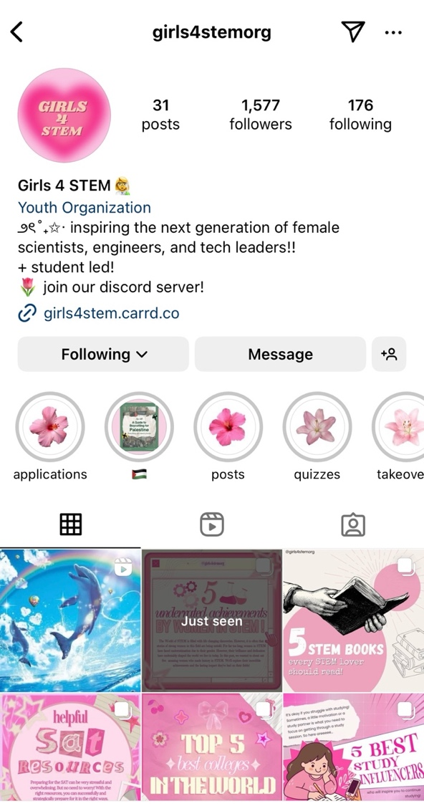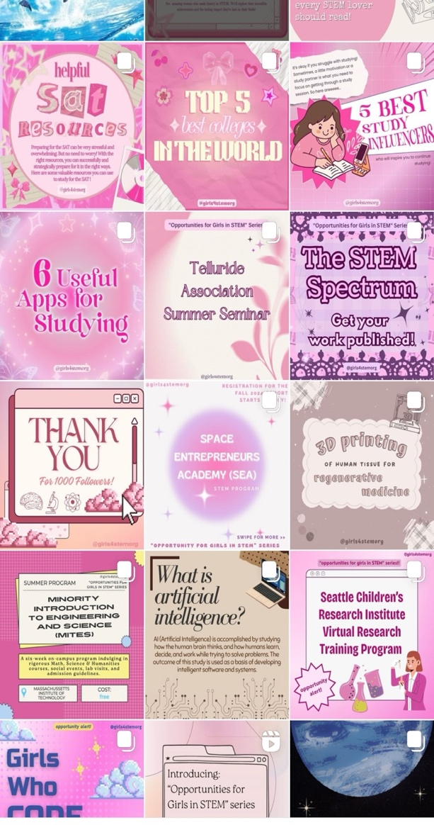
Figure 1. Girls for STEM campaign at Instagram (source Instagram @girls4stemorg)
Based on the campaign, the visual appeal targets young girls and women interested in STEM. The combination of pictures and simple words aligns with basic to intermediate literacy skills for students. The combination of image, sound, music, words and symbols shows the effective use of multimodal, which fits perfectly for the digital native generation. The use of Instagram as a digital campaign platform is an excellent choice, considering that it is one of the most popular social media platforms. Furthermore, caption such as “5 underrated achievement by Women in STEM” triggers the need to honor and celebrate women’s contributions in science while sending messages about the lack of appreciation of women in STEM. However, there are some notes for improvement for this campaign. First, it offers an alternative language besides English to reach a larger audience. Then the dominant use of pink color may send a different massage that girls are only like pink, while girls can like all color. It is also great to provide diversity in representation by including profiles and stories of girls from different backgrounds succeeding in STEM that would cater to a more diverse audience.
Recommendations
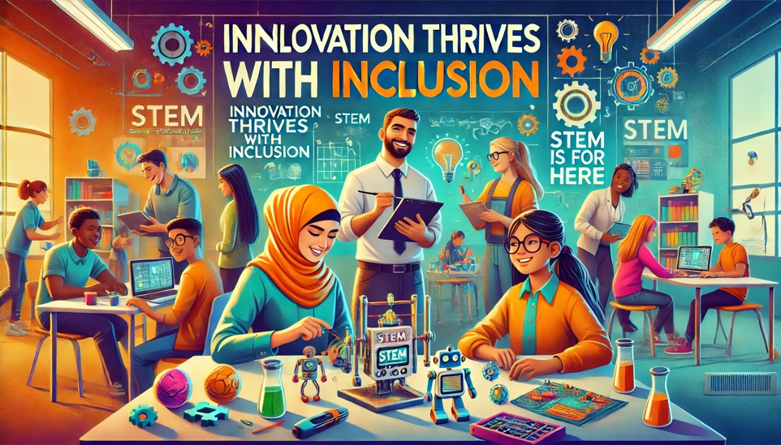
Figure 2. Inclusive STEM classroom and workplace (source: generated from ChatGPT)
Luehmann et al. (2024) recommend adopting a justice-centered perspective to critique the role of culture and pedagogy in reinforcing gender bias (e.g., culturally sustaining pedagogies in rural education). It emphasizes engaging students in high-leverage practice to act on the issue in a way that can make an impact. To encounter gender bias embedded in cultural and social narratives, it urges teachers to unpack their bias by analyzing their education and social background. To communicate the issue, teachers play a critical role in mediating STEM content for students, emphasizing the importance of aligning communication to students’ developmental stages and existing stereotypes.
Figure 2 depicts an ideal visualization of an inclusive STEM classroom and workplace where pictures and words are easy to understand so that all girls and boys feel welcome in this field. Bringing inclusive values, an asset-based perspective, and a sense of belonging would sustain girls in STEM fields. For example, teachers can provide diverse STEM textbooks, videos or multimodal sources portraying men and women. Additionally, having female role models to guide female students positively affects their attitudes toward STEM careers. Therefore, “inviting successful female scientist and professional visit can be part of the STEM curriculum” (Wang & Degol, 2017, p. 131). Importantly, female students cannot be viewed as one group who have “similar needs, experiences and barriers to social progress” and African American and Latina groups are often underrepresented in STEM discourse compared to White and Asian female students (Wang & Degol, 2017, p. 133). Designing instructional learning to incorporate students’ cultural and historical backgrounds is a real act of social justice. School policy should also show proactive agendas to neutralize gender discourse and avoid masculine words (dangerous, hard, messy) referring to the science profession (Scholes & Stahl, 2022). Therefore, learning resources and instructions that provide both boys and girls with the ability to thrive in STEM fields are an act to present social justice in classroom settings.

Excellent work, Waode! You thoroughly address each aspect of the rubric and shed light on a social justice issue that has a great deal of intersectionality. I appreciated the nuances and subtleties you addressed in how even the choice of color in conversations about STEM and women can be a deterrent. Really well done, well researched and highly relevant.
Criteria | Exceeding Expectations (9-10 Points) | Meeting Expectations (7-8 Points) | Approaching Expectations (5-6 Points) | Below Expectations (1-4 Points)
Critical Analysis (Depth of Thought)  2 possible pts total | Insightful and thorough analysis that demonstrates deep understanding of the role of literacy in mediating social justice. Critical thinking is clearly articulated and consistently applied throughout. | Solid analysis with clear understanding of the issue. Critical thinking is present but may not be consistently deep or fully developed. | Some analysis, but lacks depth. Critical thinking is present but limited or underdeveloped. Surface-level understanding of the issue. | Minimal or no critical analysis. Shows little to no understanding of the issue or the role literacy plays in mediating social justice.
Research & Documentation (Relevance and Quality of Sources)  2 possible pts total | Uses a wide range of high-quality, diverse sources. Sources are highly relevant and effectively support the analysis. Demonstrates thorough research. | Uses appropriate and relevant sources that adequately support the analysis. Some diversity in sources, but may be limited in scope. | Uses a limited number of sources, some of which may not be fully relevant or supportive of the analysis. Research is minimal. | Few or no sources used, or sources are irrelevant and do not contribute to the analysis. Little to no research evident.
Case Study (Application and Contextualization)  2 possible pts total | Case study is analyzed in-depth with clear, insightful connections to the issue. Application of literacy concepts is sophisticated and context is well-understood. | Case study is adequately analyzed with some connections to the issue. Literacy concepts are applied, though may lack nuance or depth. | Case study is mentioned, but analysis is shallow or unclear. Connections to the issue or literacy concepts may be vague or incomplete. | Little to no analysis of the case study. Connections to the issue or literacy concepts are weak or nonexistent.
Recommendations (Creativity and Practicality)  2 possible pts total | Proposes highly creative, practical, and actionable strategies for improving communication. Ideas are innovative and well-supported by analysis. | Proposes reasonable and practical strategies for improving communication. Ideas are well-thought-out, though may lack creativity or full development. | Proposes some strategies, but they may lack practicality, depth, or clear connection to the analysis. Ideas are underdeveloped. | Recommendations are missing, vague, or impractical. Ideas are not connected to the analysis or show little effort.
Reflection (Insight and Personal Connection)  2 possible pts total | Reflection is highly insightful and demonstrates deep personal connection to the issue. New insights are clearly articulated and supported by thoughtful reflection. | Reflection shows insight and personal connection to the issue. Some new insights are presented, though they may not be fully developed. | Reflection shows minimal insight or personal connection to the issue. Lacks depth or thoughtful consideration of the issue. | Reflection is missing, superficial, or lacks personal connection to the issue. Shows little to no insight.

References
Andersen, I. G. (2023). Teachers’ gender bias in STEM: Results from a vignette study. British Educational Research Journal, 49(4), 833–851. https://doi.org/10.1002/berj.3870
Girls 4 STEM. [girls4stemorg]. (2024). Instagram. https://www.instagram.com/girls4stemorg?igsh=MTFtemliaHI5Zzc5ag==
Institut Teknologi Sepuluh Nopember (ITS). (2019, February 20). Gender bias, ITS stimulates STEM women to show off.ITS News. https://www.its.ac.id/news/en/2019/02/20/gender-bias-its-stimulates-stem-women-to-show-off/
Johnson, N. J., Koss, M. D., & Martinez, M. (2018). Through the sliding glass door: #EmpowerTheReader. The Reading Teacher, 71(5), 569–577. https://doi.org/10.1002/trtr.1659
Luehmann, A., Zhang, Y., Boyle, H., Tulbert, E., Merliss, G., & Sullivan, K. (2024). Toward a justice‐centered ambitious teaching framework: Shaping ambitious science teaching to be culturally sustaining and productive in a rural context. Journal of Research in Science Teaching, 61(2), 319–357. https://doi.org/10.1002/tea.21917
Luke, A. (2012). Critical literacy: Foundational notes. Theory Into Practice, 51(1), 4–11. https://doi.org/10.1080/00405841.2012.636324
Maharani, R. (2021, July 14). Will Indonesia’s 4.0 revolution leave women behind? Indonesia at Melbourne. https://indonesiaatmelbourne.unimelb.edu.au/will-indonesias-4-0-revolution-leave-women-behind/
OpenAI. (2024. Inclusive STEM classroom and workplace [AI-generated image]. ChatGPT. https://chat.openai.com/
Reese, D. (2013). Critical indigenous literacies. In J. Larson & J. Marsh (Eds.), The SAGE Handbook of Early Childhood Literacy (pp. 251–262). SAGE Publications. https://doi.org/10.4135/9781446247518.n14
Scholes, L., & Stahl, G. (2022). ‘I’m good at science but I don’t want to be a scientist’: Australian primary school student stereotypes of science and scientists. International Journal of Inclusive Education, 26(9), 927–942. https://doi.org/10.1080/13603116.2020.1751316
Wang, M. T., & Degol, J. L. (2017). Gender gap in science, technology, engineering, and mathematics (STEM): Current knowledge, implications for practice, policy, and future directions. Educational Psychology Review, 29(1), 119–140. https://doi.org/10.1007/s10648-015-9355-x

